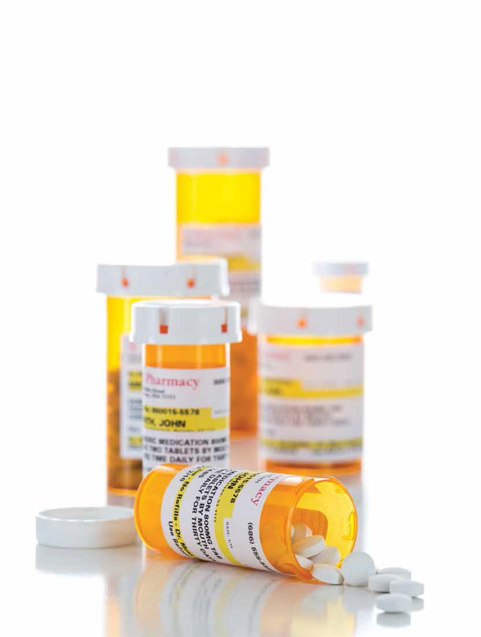
By Jane Biehl

26 Hearing Loss Magazine Visit us at hearingloss.org and follow @HLAA on Twitter

Ototoxic Medications
Is It Better to Be Deaf Than Dead?

26 Hearing Loss Magazine

The world is getting fainter and fainter. You are missing more and more of the sounds you heard before. It seems as
if it has all happened suddenly, but as you think back, it was gradual. When you listen to music, you no longer hear the words of songs on the radio or iPod. You are asking people to repeat themselves more often. You are confusing words that sound and look alike on the lips, such as “bird” and “burn.” The telephone, even on speaker mode, is becoming a huge barrier, so you avoid using it if at all possible.
Sometimes hearing loss can be due to a disease, genetic problems, or illness. Presbycusis is hearing loss due to aging, and is frequently cited as the reason for hearing loss if you are age 50 or older. Most hearing aid dispensers, doctors, and audiologists automatically diagnose a hearing loss as presbycusis in an older person.
Another lesser known but common cause of a hearing loss could be from the effects of an ototoxic medication. ”Ototoxic” refers to a drug or noise pollution that causes damage to the ear, resulting in hearing loss and balance issues. Medscape (2016) defines it as “any drug with the potential to cause toxic reactions to structures in the inner ear, including the cochlea, vestibule, semicircular canals and otoliths.” Consequences can be hearing loss, tinnitus,
or dizziness and balance problems.

The Need for More Information
One of the many problems with ototoxic medications is that doctors, audiologists, and patients are typically not educated on this issue. It has been happening for a very long time. My first deaf friend lost her hearing in the 1920s at the age of 13 from the drug quinine. Now there is more research being done, but not enough. Another problem is that professionals and consumers are not getting the infor- mation they should with the research that is being done.
The best way to think of ototoxicity is ear poison-
ing. Neil Bauman, Ph.D., one of the leading researchers of ototoxic medications, states there are more than 740 drugs which are known to be ototoxic. Some of the more com- mon ones include chemotherapy drugs such as Cisplatin. Virtually everyone who is prescribed this drug ends up with a hearing loss (Bauman, 2010). Talska and Schacht (2010) explain that most of the damage to the ears is caused by the medication killing the hair cells in the cochlea, resulting in hearing loss.
Two classes of medications known to be ototoxic are the aminoglycosides (or the “mycin” drugs) and certain an- tibiotics. The aminoglycosides Neomycin and Tobramycin, and antibiotics Erythromycin and Vancomycin, can all be dangerous when used in large amounts. Generally, these are

dangerous if administered intravenously (IV). For a long time I thought these medications were ototoxic only if administered by IV. Now, however, we know hearing loss can also be caused by taking them orally. Neomycin is the most toxic drug to the structure involved in hearing—the cochlea—and is recommended for topical use only (League for the Hard of Hearing, 2000).
Other classes of drugs that can potentially cause damage include nonsteroidal anti-inflammatory drugs, or NSAIDs. Some of the better known names include ibuprofen (Motrin, Advil, and Nuprin) and naproxen
(Naprosyn, Anaprox, and Aleve). The positive news is that once use of these medications is discontinued the effects are usually (but not always) reversible (Kaufman, 2000).

There are more than 740 drugs which are known to be ototoxic. The consumer must be proactive. If you find you are on an ototoxic drug, be sure to discuss it with your hearing professional
and doctor.
Diuretics, particularly loop diuretics, are another dangerous class of drugs that can cause hearing loss. Rosen (2014) explains that commonly used diuretics such as Lasix and Bumex damage blood vessels in the inner ear. Conse- quently this will interfere with signals from the auditory nerve to the brain.
One of the most surprising ototoxic medications is aspirin, a very well-known and common drug. The Ameri- can Association of Retired Persons (AARP) has joined several other organizations in warning people about the dangers of aspirin and other painkillers (Rosen, 2014).
The Northern Virginia Resource Center (2010)
and Kaufman (2000) join Dr. Bauman in warning that certain medications such as Prednisone and anesthetics like the well-known Lidocaine can also cause tinnitus. Tinnitus is a “ringing in the ears” when there is no actual sound present.
It is estimated that 80 percent of people with hearing
loss have tinnitus and 80 percent of people with tinnitus have hearing loss, but it is not a one-to-one correlation. In other words, having hearing loss does not necessarily mean someone has tinnitus, and having tinnitus does not neces- sarily mean someone has hearing loss. However, people with hearing loss are more likely to have tinnitus than those who don’t (Beck, 2012).
There are more than 200 drugs that are known to cause tinnitus and surely more that are under suspicion
continued on page 28

Like HearingLossAssociation on Facebook July/August 2017 27

OTOTOXIC MEDICINES continued from page 27
(Hearing Health Foundation, 2017). Thus, tinnitus can be a warning to the consumer that an early hearing loss is occurring.

The Effects of Noise
One of the most overlooked ototoxic causes of hearing loss is noise pollution. People tend to grossly underestimate the impact noise has in our everyday lives.
Indeed, according to an article in Hearing Health
(Summer 2001), the football stadium where the Denver Broncos play was actually intentionally designed to be the loudest stadium in the NFL. During most games the noise averages 90-100 decibels. To put this into perspective, the Occupational Safety and Health Administration (OSHA) states that employees can be exposed to 110 decibels of noise for no longer than 30 minutes, or 115 decibels for no longer than 15 minutes without risking permanent damage. OSHA recommends employees wear hearing protection at 85 decibels.
It doesn’t take long to figure out what kind of assault Denver’s fans are experiencing. Almost all of us have been
to rock concerts, wedding receptions and other places where our ears are ringing after we leave. What we are seldom told is that when this happens, the hair cells in the ears are being destroyed and will never grow back again (NIDCD, 2015).
Repeated incidents of exposure, whether through
noise or drugs, will inevitably cause hearing loss. One article which emphasizes this is The Ototoxic Drug Dilemma: You Live, Hair Cells Die (Talaska and Schacht, 2010). Most people, of course, believe that the lesser of two evils is becoming deaf rather than dying from a disease.

Noise in the Military
A very sad fact is that noise-induced hearing loss is now an epidemic in the military. CBS News, in a segment called Hearing Loss Now a Military Epidemic (2008), revealed that hearing damage is the number one disability among veterans. The Department of Veterans Affairs
(VA) has offered some startling and little-known statistics. Nearly 70,000 of the more than 1.3 million troops who have served in Iraq and Afghanistan are collecting disability compensation for tinnitus, and more than 58,000 are on disability for hearing loss.
Noise-induced hearing loss does not always occur over time. A roadside bomb, a shotgun close to the ear, or the sound of artillery can cause a permanent hearing loss. The military has a dilemma; they issue earplugs, but many soldiers don’t wear them. The reason is they are afraid of not
being able to hear sounds in the field—sounds that could save their lives or be life-threatening.
The overall statistics of noise-induced hearing loss are staggering. The National Institute on Deafness and Other Communication Disorders (NIDCD, 2015) states that approximately 14 percent of Americans between the ages
of 20 and 69—that’s 26 million people—have hearing loss that might have been caused by the effects of noise.
Bauman (2010) reminds us how insidious ototoxic
poisoning can be. If a person combines an ototoxic drug with exposure to noise pollution, the synergistic effects can last long after the drug has been discontinued.
Cisplatin, a medication commonly used for chemo- therapy, can remain in the fluids of the inner ear for up to a year. Drugs linger in the inner ear fluids long after they have left the bloodstream. If a doctor warns a patient about exposure to noise pollution while on a medication, the patient must remain cautious for a long time.

The Prevalence of Ototoxic Drugs
Still another drug that can be ototoxic in large doses is Vico- din. First released to the market in 1982, by the year 2000 Vicodin had became the most prescribed drug in America. When used appropriately, it is not considered dangerous, but many patients abuse this drug and lose their hearing.
The House Research Institute in Los Angeles and several other medical centers have reported a steady stream of addicts, who in addition to battling addiction, are now facing a hearing loss. In some cases stopping the drug can bring back hearing, but in other cases the damage is irrevers- ible. Thus, older drugs are now being discovered as ototoxic.
Marsda wrote an article in 2001 pointing out the dangers of Vicodin. Bauman (2010) issued a similar warning in his book nine years later. Yet professionals and consumers still aren’t educated on this dangerous drug if taken incorrectly.
In a Hearing Loss Magazine article that appeared in
the March/April 2013 issue, Monique Hammond also points out that new drugs are not routinely tested for ototoxicity. She explains that as more and more drugs are being pumped into the market, the confusion will only grow. The available information comes from reports after a drug has been released to the market. Manufacturers must report any adverse reactions to the Food and Drug Admin- istration (FDA). Consumers are encouraged to report any problems they have experienced from a drug to the FDA MedWatch program.

What Can Consumers Do?
So what can we, as consumers, do? This topic is particularly important to me because I have had a severe hearing loss

28 Hearing Loss Magazine Visit us at hearingloss.org and follow @HLAA on Twitter

for more than 50 years. I was diagnosed with cancer and put on an oral dose of chemotherapy. I knew that chemo drugs could be ototoxic, but most of them are administered through an IV. However, since the drug I was on was taken orally I did not worry. That is, until my hearing deteriorated significantly, to the profound level.
Knowledge is power. For years no one knew anything about these drugs. Fortunately, more articles and research are being published. The AARP is constantly warning its members about the dangers of ototoxic medications (Bouton, 2016).
Neil Bauman is considered the guru of ototoxic medications. An invaluable resource is his book Ototoxic Drugs Exposed: The Shocking Truth About Prescription Drugs, Medications, Chemicals and Herbals That Can (and Do) Damage Our Ears (2010). This exhaustive book even notes herbals that can cause hearing loss. It is a great idea to visit your library and look up Dr. Bauman’s extensive work.
He has information on hundreds of drugs, including their trade names, common and generic names, and detailed side effects. The section on herbal drugs outlines possible side effects of common foods such as garlic and green tea, and even reports on the effects of marijuana.

Help Yourself!
The consumer must be proactive. If you find you are on an ototoxic drug, be sure to discuss it with your hearing
professional and doctor. You especially need to be concerned if you have taken the drug for longer than the manufacturer recommends. If you already have a hearing loss, the danger is increased.
Tinnitus and balance problems are often an early sign
of hearing loss. Your hearing professional needs to be test- ing for higher-frequency hearing loss. These are the sounds of the consonants in the alphabet, a female voice, a high- pitched sound, or a musical note. Most standard testing begins at 250-8,000 Hertz (Hz; the number of cycles per sound). But according to Bauman, a hearing loss can begin at 10,000-16,000 Hz.
If the patient trusts the professional, why do they need to be assertive and proactive? Elaine Suss explained in a book published many years ago, When the Hearing Gets Hard‚Winning the Battle Against Hearing Impairment (1993), part of the problem is that the drug is frequently listed under the its trade name and not its generic name. Both need to be researched.
This is exactly what happened to me. Nowhere in the literature was there any warning about toxicity for the chemo drug Revlimid. My hearing had continued to dete- riorate. At first my audiologist dismissed the possibility of the drug being the cause of the loss, but when I persisted,
she realized that there was a serious problem. My oncologist did not know if the drug was dangerous, but pointed out
I had been on it for much longer than most people. Both
of them are fantastic professionals and worked with me to find out more.
I began to do research and found out that thalido- mide is an ototoxic drug and Revlimid is a derivative of that (Bauman, 2010). The company which produced the drug refused to listen to me. I now have only a very small amount of hearing in both ears. Eventually the Revlimid failed to work and I was placed on Vidaza, which a major university cancer center told me is known to cause hearing loss.
My audiologist tests my hearing every couple of months and sends the reports to my oncologist, who also monitors me carefully. I do not have the choice of
another drug, or not taking it at all, because of the cancer. The drug I am on now is the only option for treatment of this rare type of cancer. Thus, it is a choice of life or losing my hearing. As I said to my oncologist, “I guess it is better to be deaf than dead.” But we also know how difficult being deaf can be.
So the consumer needs to be knowledgeable, stay on top of the research, turn to places like HLAA, and involve the professionals. I am just thankful that today, more than ever, we know about the dangers of drugs and that we have agencies and people to help us. HLM

Jane Biehl, Ph.D., is a
30-year member of HLAA from North Canton, Ohio. She has had several suc- cessful careers as a librar- ian, counselor and college teacher. Presently Dr. Biehl is a professional writer and has written several articles for Hearing Loss Maga- zine. She has also presented
at several HLAA Conventions. Dr. Biehl and her hearing ear dog, Sita, have a website—sitaandjane.com—where you can find more information.

Take the #HearingLossChallenge. Visit hearingloss.org for more info!

Like HearingLossAssociation on Facebook

